**Docker Assignment 5**

**You have been asked to:**

● Create a sample HTML file

● Use the Dockerfile from the previous task

● Replace this sample HTML file inside the docker container with the default page

**A. Create a sample HTML file**

**Step 1: First, we** will **create** an **index.html** file **using** the **command**: **sudo nano index.html.**

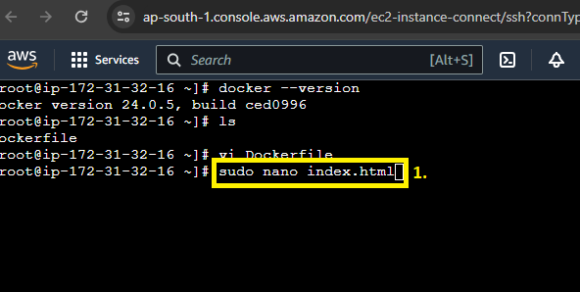

**Step 2: Paste** the **below-given code in** the **index.html file.**

<!DOCTYPE html>

<html>

<head>

<title>Page Title</title>

</head>

<body>

<h1>This is a Heading</h1>

<p>This is a paragraph.</p>

</body>

</html>

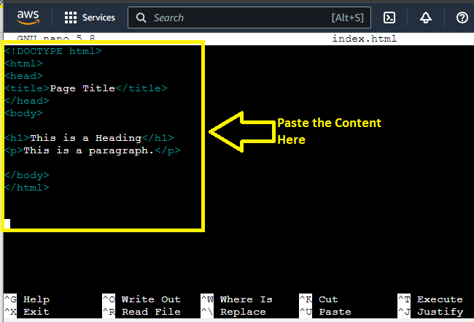

**Step 3:** **Do CTRL+X** & **press Y** for **saving** the **file. Press “enter”** & **your file** will be **saved.**

**B. Use the Dockerfile from the previous task**

**Step 1: Now, we** will **add** the **index.html file** to the **/var/www/html location. Run** this **command: vim Dockerfile.**

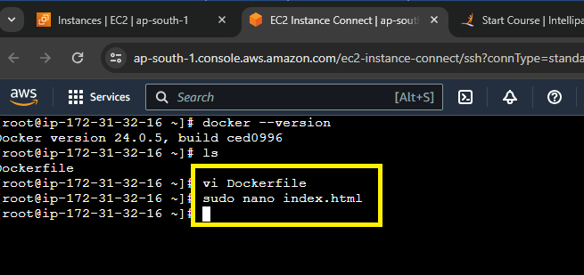

**C. Replace this sample HTML file inside the docker container with the default page**

**Step 1: Add** this **command** to **the Dockerfile: ADD index.html /var/www/html/**

**Do :wq! - To quit & save the file.**

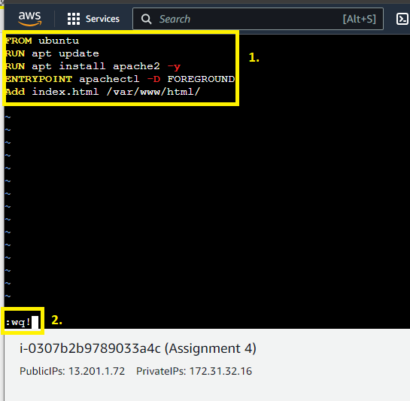

**Step 2: Now, we** will **create** a **separate image** using **the Dockerfile.**

**Use this command: docker build –t assignment5 .**

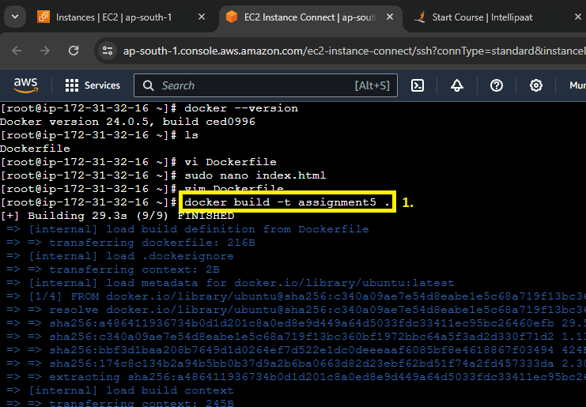

**Step 3: Now, we** will **create** a **new container using** the **created image through** this **command: “docker container run –itd –p 89:80 –name testcont1 assignment5”**

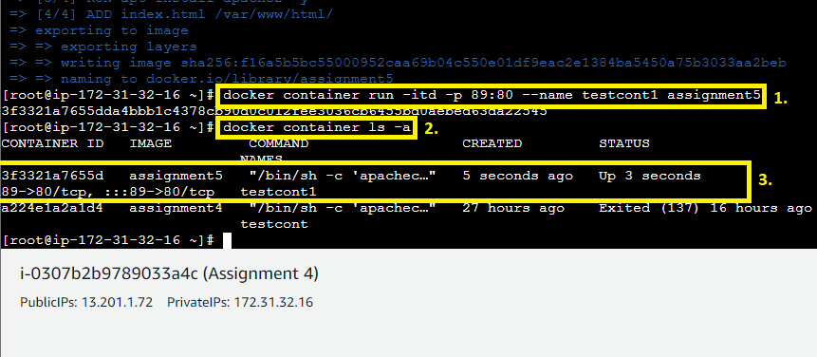

**Step 4: Go inside** into the **container using** this **command: “docker container exec –it testcont1 bash”.**

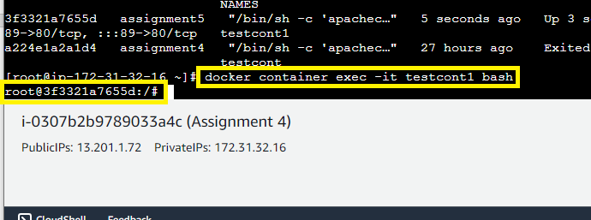

**Step 5: Run** these **commands:**

**cd /var/www/html/ - To go inside into the html folder.**

**Type “ls” to view the file present into “html directory”.**

**You** will **notice** that **the “index.html” file** will be **present** into the **“html” directory.**

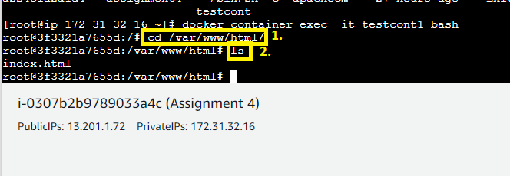

**Step 6: Run** this **command: “cat index.html” file. You** can **easily view** the **content** ofthe **index file.**

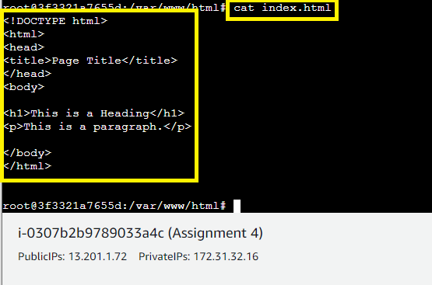

**Step 7: Now, go** tothe **“Instances”** & **copy** the **“IP Address”** from the **“Public Address”** section.

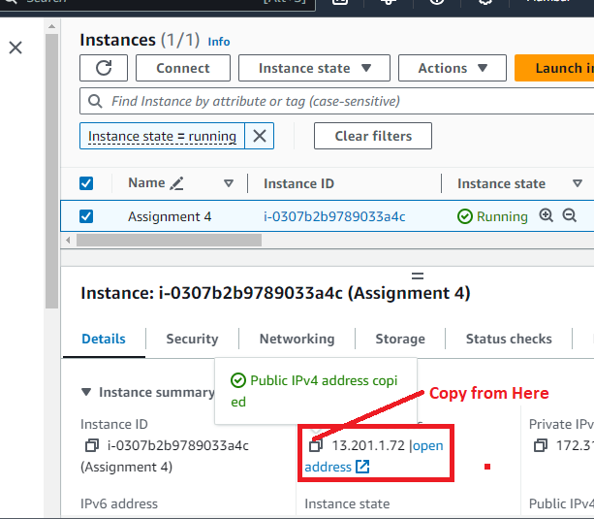

**Step 8: Paste** the **13.201.1.72:89 into** the **browser address bar** & **your index.html file content** will be **shown** in the **browser.**

